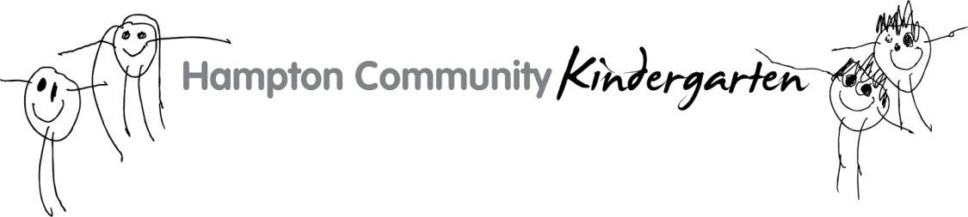

CONFIRMATION OF OFFER

PLEASE COMPLETE THIS FORM TO ACCEPT YOUR CHILD’S PLACE FOR NEXT YEAR AND RETURN TO THE KINDERGARTEN BY MONDAY 13th AUGUST
BY EITHER POSTING TO 1A MYRTLE RD HAMPTON 3188 OR VIA EMAIL

3 Year Old Email: en_officer_3yo@hamptoncommunitykinder.org.au
4 Year Old Email: en_officer_4yo@hamptoncommunitykinder.org.au

*If you have an application reference number provided by Bayside City Council please record here ____________________

Once your child’s place has been processed, you will receive a confirmation email confirming which group your child has been allocated to. This email will also outline the details for our AGM (Annual General Meeting) to be held on November 13th 2018 to which you are required to attend in order to receive more information about the kinder program for next year.

CHILD INFORMATION

Family Name: ____________________________ Date of Birth: ___ / ___ / ___

Given Name/s : ______________________ Preferred Name: _________________

Gender:

- Male

- Female

- Other ___________________

Language Spoken at Home: __________________________________________

*Please note that the kindergarten requires a copy of your child’s up-to-date immunisation records and birth certificate to complete the enrolment process.
PRIMARY FAMILY HOME ADDRESS

No. & Street: _____________________________________________________

Suburb: ____________________________ State: _______ Postcode: _______

Contact Name: ____________________________________________________

Contact Number: __________________________________________________

Email: ___________________________________________________________

Parent/Guardian Signature: _________________________________________

FOUR YEAR OLD GROUP PREFERENCE

Please select one option if your child will be attending 4 Year Old Kinder in 2019. Please note that groups will be allocated via the order the forms are received.

 | Wombat Group | Wednesday  Friday | 8:30am – 4:00pm  8:30am – 4:00pm
 | Echidna Group | Monday  Tuesday  Thursday | 8:30am – 4:00pm  12:00pm – 4:00pm  12:30pm – 4:00pm
 | No Preference
PAYMENT

To secure your child’s place, a non-refundable deposit of $250 needs to be paid (eligible concession holders are exempt) via direct deposit by Monday 3rd December into the bank details provided below:

Bank: Bendigo Bank Account Name: Hampton Community Kinder
BSB: 633 000 Account Number: 158395541
Payment Ref: Child’s Family Name and initial

